Setting up your

Pre-Approval Agreement
Follow the link you have been given.
You will see the page below. If you have a PayPal account already, just enter your username and password:
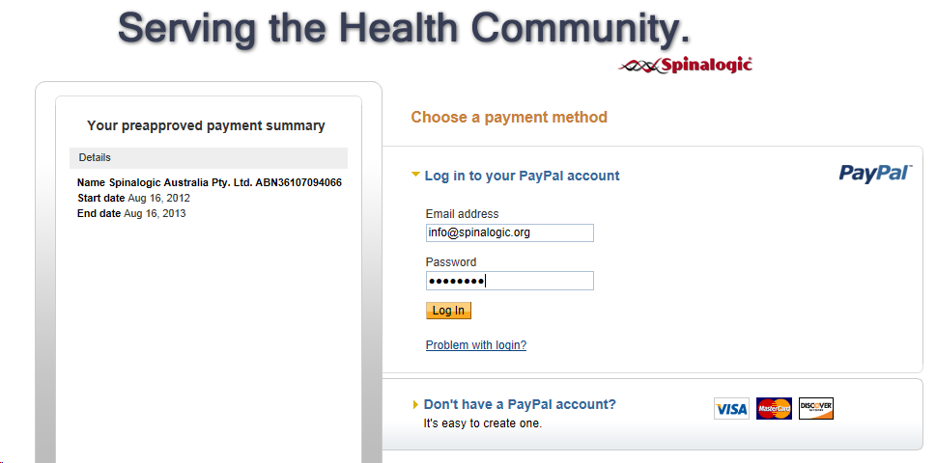
If you don’t have a PayPal account, don’t panic! It’s easy and takes 5 min to set up. Just click the link that says ‘Don’t have a PayPal account?’ and you will see a simple form:
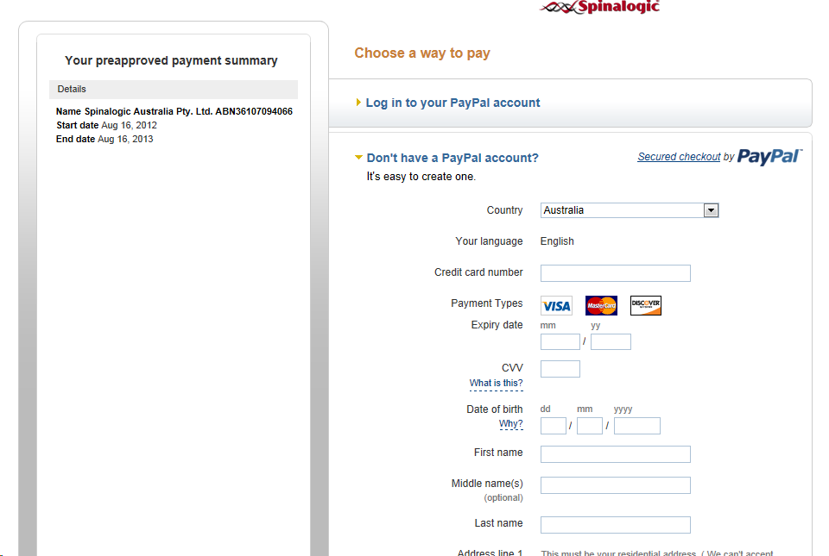
Once you’re logged in, you’ll see:
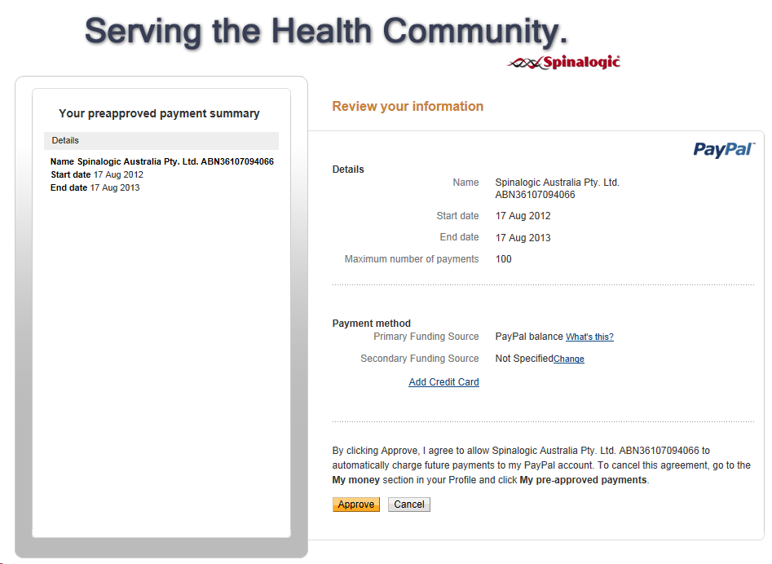
Just click ‘Approve’ and you’re done!

