How to add or edit a Credit Card or Bank Account
You can set Zero-Touch to use any credit card or bank account you choose. This is service provided by PayPal and the accounts you can use will vary depending on the country your PayPal account is based in.
Log in to PayPal at http://paypal.com.au
In the ‘My Account’ Tab, hover over ‘Profile’
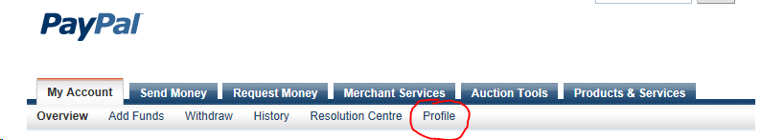
Select ‘Add or Edit Credit Card’ or ‘Add or Edit Bank Account’
To authorize a bank account, PayPal will make two small deposits to your account. You need to find them in your statement and enter them back into your PayPal account. It can take a few days for those little deposits to show in your account. Once you put those values into PayPal, your account is instantly authorized.
Once it is authorized, you can change ZeroTouch to use your new account. See “How to change the account your Zero Touch Payments come from”

How to change the account your Zero Touch Payments come from
In PayPal, you can have a number of linked accounts. Here’s how to choose which one is used for your Payments at Bonfire.

Part A
Log in to your PayPal Account
If it’s easier, click or type in this link: https://www.paypal.com/au/cgi-bin/webscr?cmd=_ap-manage-preapprovals . You can go directly to Part B below.
Otherwise.. just click through a few steps in the PayPal menu:
Click on ‘Profile’
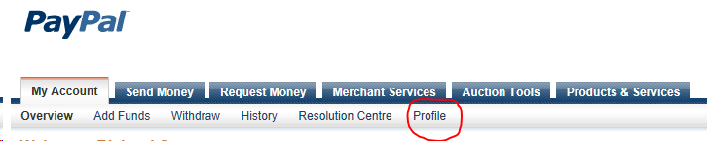
Select ‘My Money’
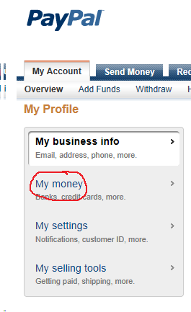
Click ‘Update’ at the end of ‘My pre-approved payments’
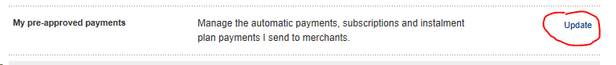
Follow the link to the pre-approved payment plans page
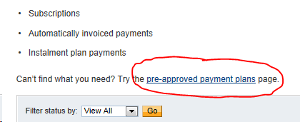

Part B
Click on the ‘Spinalogic Australia...’ link:
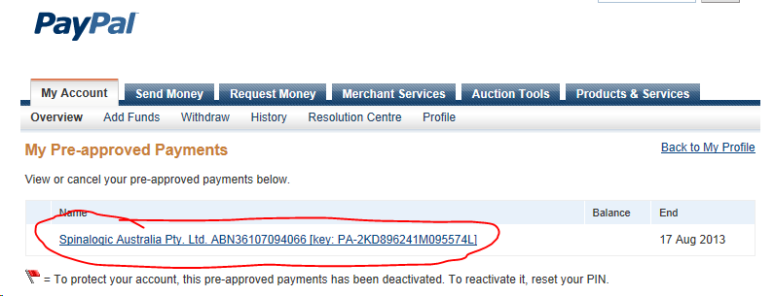
..and you’ll see this:
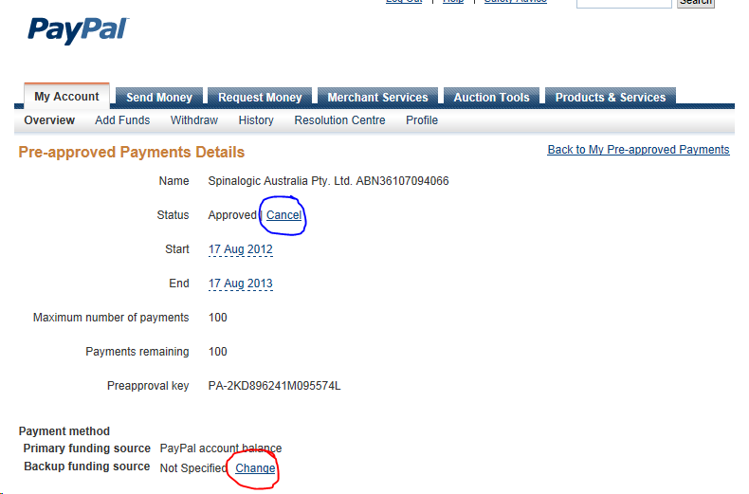
At the bottom, click ‘Change’ to change your backup funding source. Paypal credit will always be used first.
You can cancel your agreement at any time yourself with the link circled in blue above. You are always in control.

